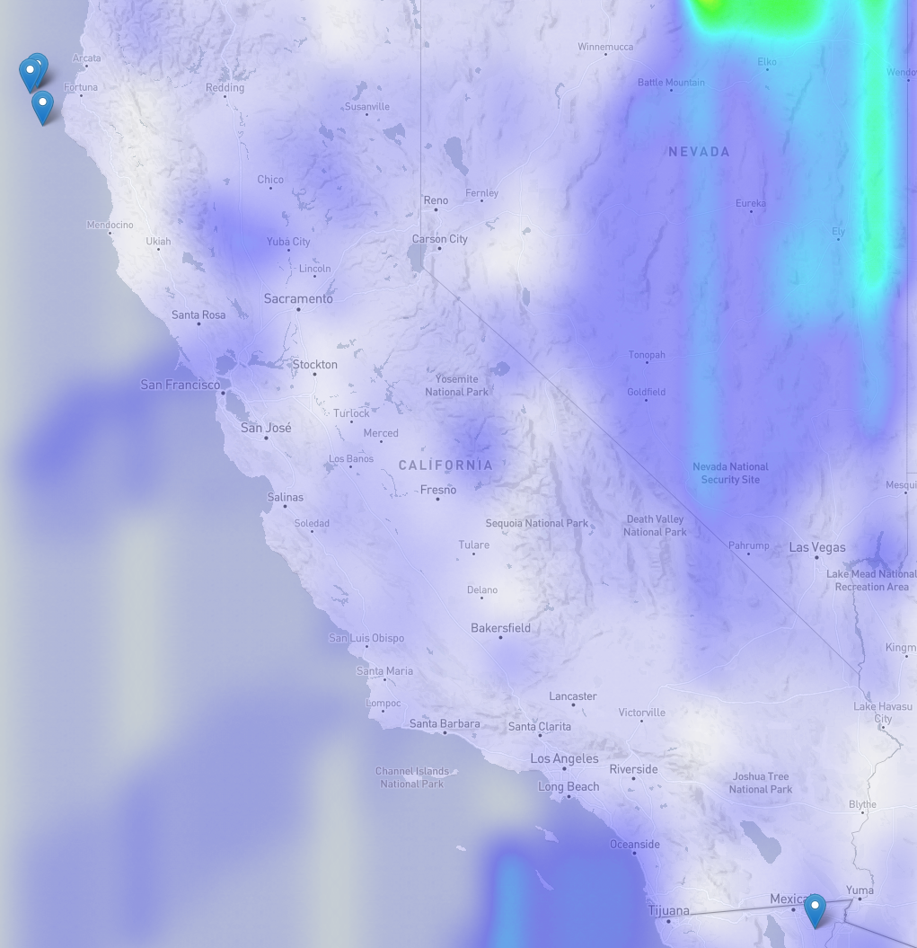

Eureka Quake

January 10, 2010, 16:27 PST

Magnitude: 6.5

Mean Temperature Change: 2.63

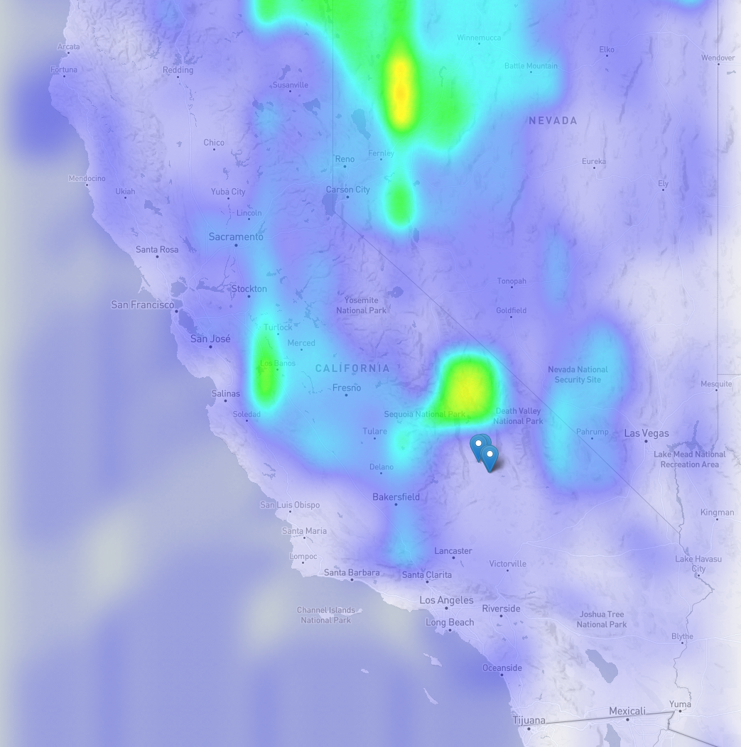Ridgecrest Quake

July 5, 2019, 22:19 PDT

Magnitude: 7.1

Mean temperature change: 2.81

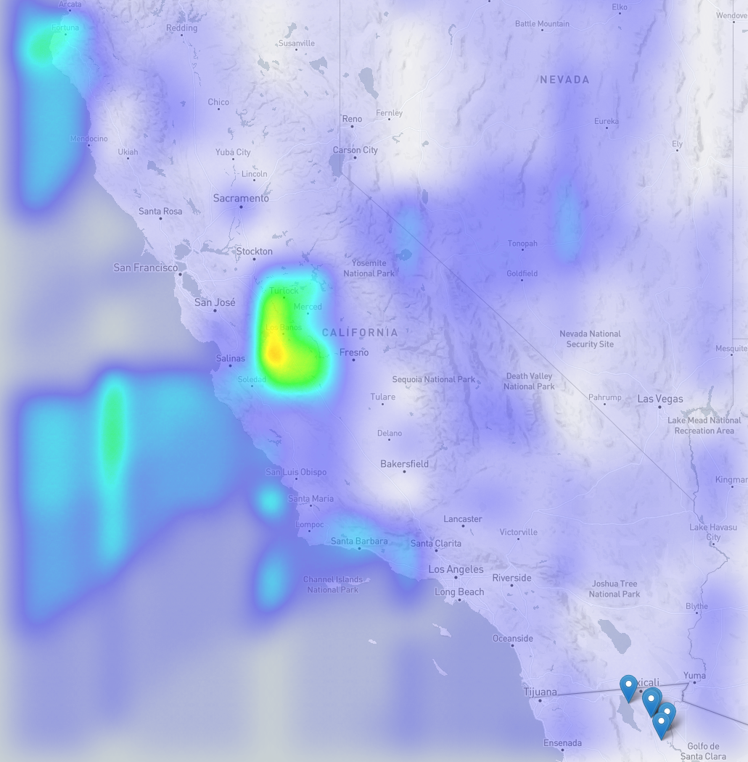

Baja California Quake

April 4, 2010

Magnitude: 7.2

Mean temperature change: 2.13

This description is for the main map:

Tohoku (Japan) Quake

March 9, 2011

Magnitude: 7.2

Mean Temperature Change: 1.9

This map of Japan shows the foreshocks, mainshock and aftershocks of the Tohoku quake that caused a tsunami in 2011. The heatmap represents the change in temperature from the day before and the day of the quake. With red being the biggest change and faint purple representing a change of less than 1oF

Collecting temperature data for 1,258 lats/longs.

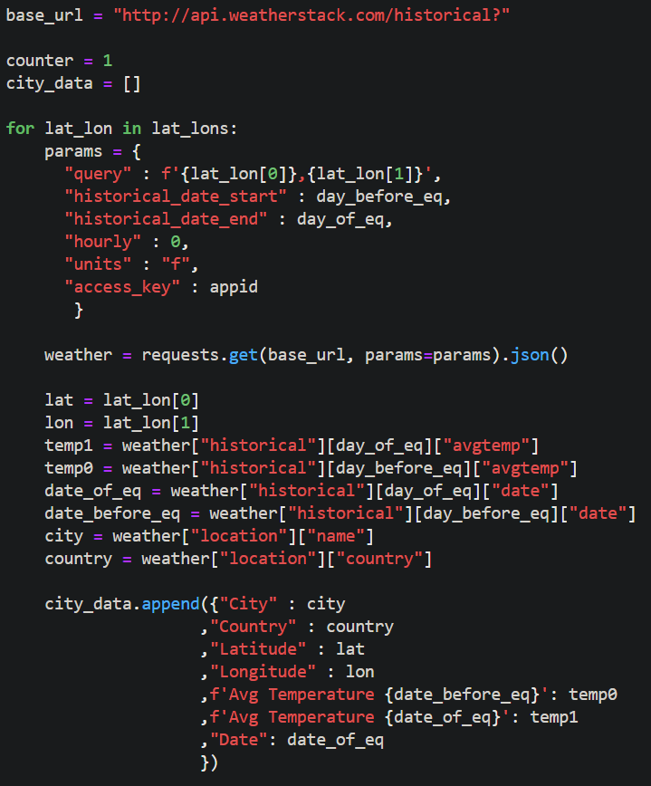

Creating the heatmap layer using D3.

